The Answer for the Q1(t):

[t u v]= [0.45465943 0.4279049 0.44592201]

The point on the polynomial surface is (2.1395245, 2.22961, 1.6185411)

The point on the query curve is (2.2732972, 2.2732972, 3.966899)

Distance=2.3526

The Answer for the Q2(t)

[t u v] =[ 0.18397847 0.3617049 0.19776396]

The point on the polynomial surface is (1.8085245, 0.98881978, 1.5691985)

The point on the query curve is (0.91989237, 0.91989237, 4.2690505)

Distance=2.8432

The following is some discussion.

M-file for Q1(t)

%t,u,v are variables

syms u v t

syms h real

digits(8)

%h is step size

%u,v is from 0 to 1

x=5*u;

y=5*v;

z=(-0.38)+25/3*u+4/3*v-25/3*u*u-10/3*u*v;

%Q1t, t is from 0 to 1

qx=5*t;

qy=5*t;

qz=25/6*t*t-25/6*t+5;

distancesquare=(x-qx)^2+(y-qy)^2+(z-qz)^2;

%diff(distance,'t'),diff(distance,'u'),diff(distance,'v');

Ft=diff(distancesquare,'t');

Fu=diff(distancesquare,'u');

Fv=diff(distancesquare,'v');

%t0,u0,v0 are initial point;

t0=0.5;

u0=0.5;

v0=0.5;

for i=1:100

%deltat,deltau,deltav are numbers of partial derivation

deltat=eval(subs(Ft,[t,u,v],[t0,u0,v0]));

deltau=eval(subs(Fu,[t,u,v],[t0,u0,v0]));

deltav=eval(subs(Fv,[t,u,v],[t0,u0,v0]));

%t1,u1,v1 are variables

t1=t0+deltat*h;

u1=u0+deltau*h;

v1=v0+deltav*h;

newdistancesquare=subs(distancesquare,[t,u,v],[t1,u1,v1]);

%new t0,u0,v0

g=diff(newdistancesquare,'h');

h0=vpa(solve(g,h));

[r,c]=size(h0);

if r~= 1

h0=h0.*((t0+deltat*h0>=0).*(t0+deltat*h0<=1).*(u0+deltau*h0>=0).*(u0+deltau*h0<=1).*(v0+deltav*h0>=0).*(v0+deltav*h0<=1));

h0(find(h0==0))=[];

end

t0=t0+deltat*h0;

u0=u0+deltau*h0;

v0=v0+deltav*h0;

end

point_tuv=[t0,u0,v0]

distance=sqrt(eval(subs(distancesquare,[t,u,v],[t0,u0,v0])))

x=5*u0

y=5*v0

z=(-0.38)+25/3*u0+4/3*v0-25/3*u0*u0-10/3*u0*v0

qx=5*t0

qy=5*t0

qz=25/6*t0*t0-25/6*t0+5

Figure1

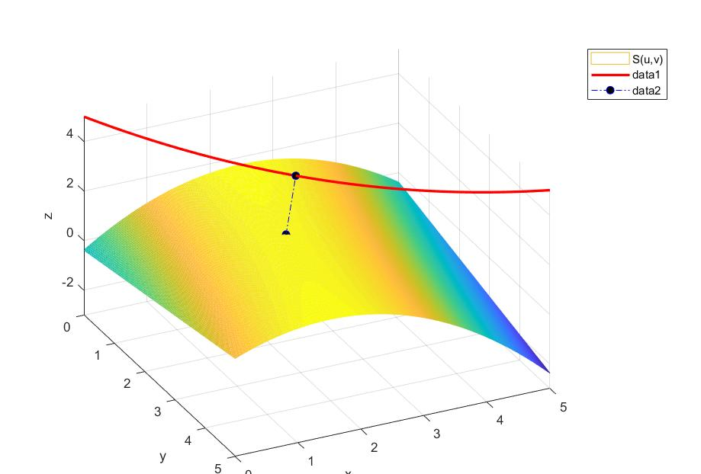

M-file for Q2(t)

%t,u,v h are variables

syms u v t

syms h real

digits(8)

%h is step size

%u,v is from 0 to 1

x=5*u;

y=5*v;

z=(-0.38)+25/3*u+4/3*v-25/3*u*u-10/3*u*v;

%Q1t, t is from 0 to 1

qx=5*t;

qy=5*t;

qz=53.976*t^4-104.64*t^3+64.256*t^2-12.589*t+5;

distancesquare=(x-qx)^2+(y-qy)^2+(z-qz)^2;

%partial derivative,expression;

Ft=diff(distancesquare,'t');

Fu=diff(distancesquare,'u');

Fv=diff(distancesquare,'v');

%t0,u0,v0 are initial point , numbers;

t0=0.5;

u0=0.5;

v0=0.5;

for i=1:100

%deltat,deltau,deltav are numbers of partial derivation

deltat=eval(subs(Ft,[t,u,v],[t0,u0,v0]));

deltau=eval(subs(Fu,[t,u,v],[t0,u0,v0]));

deltav=eval(subs(Fv,[t,u,v],[t0,u0,v0]));

%t1,u1,v1 are variables

t1=t0+deltat*h;

u1=u0+deltau*h;

v1=v0+deltav*h;

newdistancesquare=subs(distancesquare,[t,u,v],[t1,u1,v1]);

%new t0,u0,v0

g=diff(newdistancesquare,'h');

h0=vpa(solve(g==0,h));

A = h0 == real(h0);

h0=h0(A);

[r,c]=size(h0);

if r~= 1

h0=h0.*((t0+deltat*h0>=0).*(t0+deltat*h0<=1).*(u0+deltau*h0>=0).*(u0+deltau*h0<=1).*(v0+deltav*h0>=0).*(v0+deltav*h0<=1));

h0(find(h0==0))=[];

end

%h0 多解，考虑t0,u0，v0 大小约束

t0=t0+deltat*h0;

u0=u0+deltau*h0;

v0=v0+deltav*h0;

end

point_tuv=[t0,u0,v0]

distance=sqrt(eval(subs(distancesquare,[t,u,v],[t0,u0,v0])))

x=5*u0

y=5*v0

z=(-0.38)+25/3*u0+4/3*v0-25/3*u0*u0-10/3*u0*v0

qx=5*t0

qy=5*t0

qz=53.976*t0^4-104.64*t0^3+64.256*t0^2-12.589*t0+5

Figure 2

